|  |  |
| --- | --- |
| **WC Logo.emf** | **Staff Report to the Weber County Commission**  *Weber County Planning Division* |
|  | |

****Synopsis****

****Application Information****

**Application Request:** Request for recommendation of final approval of Angie’s Acres Subdivision, consisting of five lots, and a concurrent alternative access request.

**Type of Decision: Administrative**

**Agenda Date: Tuesday, November 30, 2021**

**Applicant: Larry Johnson, Owner**

**File Number:** LVA07192021

****Property Information****

**Approximate Address:** 300 N 5500 W, Ogden, UT, 84401

**Project Area:** 6.51 acres

**Zoning:** Agricultural (A-2) Zone

**Existing Land Use:** Agriculture

**Proposed Land Use:** Residential

**Parcel ID:** 15-025-0007

**Township, Range, Section:** T6N, R2W, Section 07 SW

****Adjacent Land Use****

**North:** Agriculture **South:** 300 North St.

**East:** Agriculture **West:** 5500 West St

****Staff Information****

**Report Presenter: Tammy Aydelotte**

**taydelotte@webercountyutah.gov**

**Report Reviewer: SB**

Applicable Land Use Codes

* Weber County Land Use Code Title 106 (Subdivisions)
* Weber County Land Use Code Title 104 (Zones) Chapter 2 (Agricultural Zones)
* Weber County Land Use Code Title 108 (Standards) Chapter 7 (Supplementary and Qualifying Regulations)
* Weber County Land Use Code Title 106 (Subdivisions) Chapter 3 (Blocks)

Background and Summary

10/12/2021 – Conditional preliminary approval granted by the Planning Commission.

11/17/2021 – Recommendation for final approval for the subdivision only, by the Planning Commission. The request for alternative access approval was denied.

An alternative access request is included with this request for final approval. The applicant is dedicating a half-width of roadway along the northern subdivision boundary, however, access to the future south-facing homes will be taken along the southern lot boundaries of lots 4 and 5, through an access easement.

The applicant is requesting final approval of Angie’s Acres Subdivision, a single-phase subdivision consisting of five lots, in the A-2 Zone. The proposed subdivision and lot configuration are in conformance with the applicable zoning and subdivision requirements as required by the Uniform Land Use Code of Weber County (LUC). The following is a brief synopsis of the review criteria and conformance with LUC.

Each of the proposed lots exceeds the minimum 40,000 square feet and 150 feet in width, as required for residential use in the A-2 zone. Two of the proposed lots do not front along a County road. LUC 108-7-31 allows for an access exception, granting access by a private right-of-way, if it is shown to be infeasible or impractical to extend a county road. Requiring a roadway through this subdivision would give a block of around 350 feet, less than the minimum required of 500 feet (LUC 106-2-3 Blocks).

Analysis

General Plan: The request is in conformance with the Western Central Weber County General Plan, as the property is being platted under the existing 1 acre zoning.

Zoning: The subject property is located in the A-2 Zone. Single-family dwellings are a permitted use in the A-2 Zone.

Lot area, frontage/width and yard regulations: The A-2 zone requires a minimum lot area of 40,000 square feet for a single family dwelling and a minimum lot width of 150 feet. All lots in this proposed subdivision meet this requirement. This subdivision is proposing an access exception, for access to lots 4-5.

As part of the subdivision process, the proposal has been reviewed for compliance with the current subdivision ordinance in the LUC § 106-1, and the A-2 zone standards in LUC § 104-2. T

Culinary water and sanitary sewage disposal: West Warren-Warren Water has issued a will-serve letter, addressing approval of secondary water system. Weber-Morgan Health Department has issued septic feasibility, and will be required to sign the final plat prior to recording the subdivision.

There is an irrigation ditch that will be piped under the proposed access easement.

Review Agencies: To date, the proposed subdivision has been reviewed by the Planning Division, Engineering Division, Weber-Morgan Health Department, and the Weber Fire District. The County Surveyor will review once a final version of the plat has been submitted for review. All review agency requirements must be addressed and completed prior to this subdivision being recorded.

Tax Clearance: There are no outstanding tax payments related to these parcels. The 2021 property taxes are not considered due at this time, but will become due in full on November 30, 2021.

Staff Recommendation

Staff recommends final approval of Angie’s Acres Subdivision, consisting of five lots located at approximately 300 N 5500 W, Ogden, UT, 84401. This recommendation is subject to all review agency requirements prior to recording of the subdivision, and the following conditions:

1. A signed deferral agreement for the roadway dedication shall be recorded with the final plat.
2. Unconditional final approval from West Warren-Warren shall be given prior to County Commission approval, or a signature on the final plat from the water company shall be obtained.
3. An access easement, for the purposes of accessing lots 3-5 along their southern boundary.

This recommendation is based on the following findings:

1. The proposed subdivision conforms to the Western Weber General Plan
2. The proposed subdivision complies with applicable county ordinances

Exhibits

1. Proposed Final Plat
2. West Warren-Warren Will Serve Letter

|  |
| --- |
|  |

****Area Map****

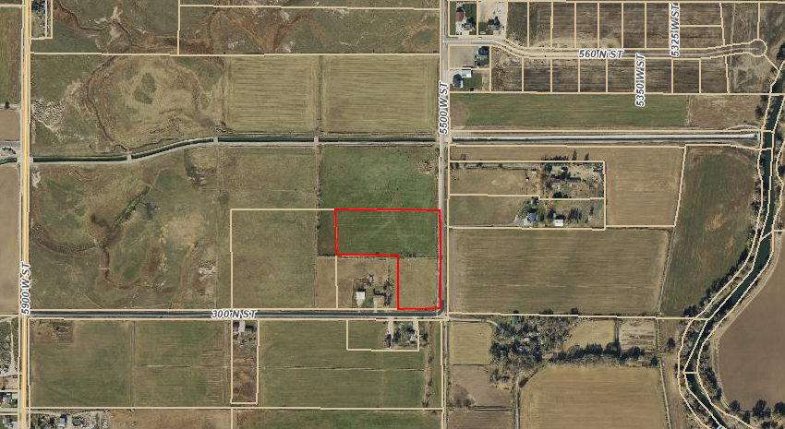

****Exhibit A – Proposed Final Plat****

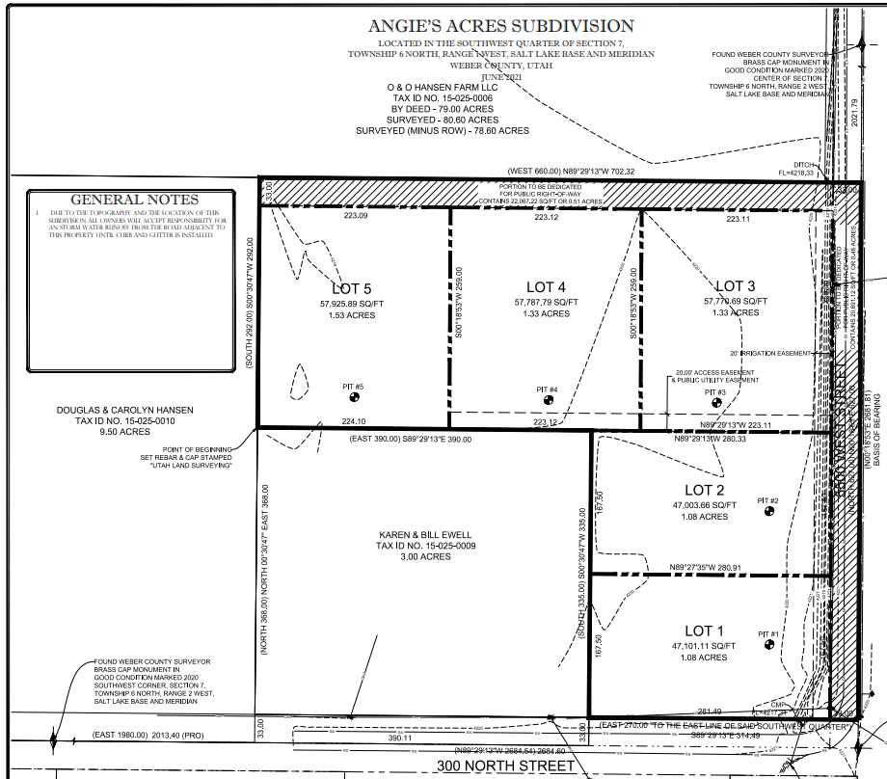

|  |
| --- |
|  |

****Exhibit B– West Warren-Warren Will Serve Letter****

